History of the Little River Chapter, Georgia Society SAR
Last Updated: April 16, 2020

Beginning in approximately 2014, the membership of the Colonel William Few Chapter of the Georgia Society SAR, headquartered in Augusta, increased rapidly to around 100. Many of the new members were coming from the areas of Thomson, Lincolnton, and Appling. Discussions began in late 2018 about exploring the possibility of forming a chapter headquartered in Thomson and serving these areas that were 25+ miles from Augusta. The Georgia Society SAR long range plan was studied, the Georgia Society SAR membership committee was contacted, and communications began about the formation of a new chapter. Members of the National Society Daughters of the American Revolution in the Captain John Wilson Chapter (Thomson) and the Burkhalter Chapter (Warrenton) were instrumental in referring potential SAR members living in the new chapter area.
The first organizational meeting was held on Thursday, February 21, 2019, at the Thomson-McDuffie Library. At this meeting, chapter officers were chosen: William J. (Bill) Tankersley, President & Registrar; Alton O. McCloud, Vice President; David A. Butler, Secretary; F. Lewis Smith, Historian & Treasurer; Don Thomas, Editor; J. David Donehoo, Chaplain; and Jackson A. Cheatham, Sergeant At Arms. Below is a photograph of those present at the first meeting:
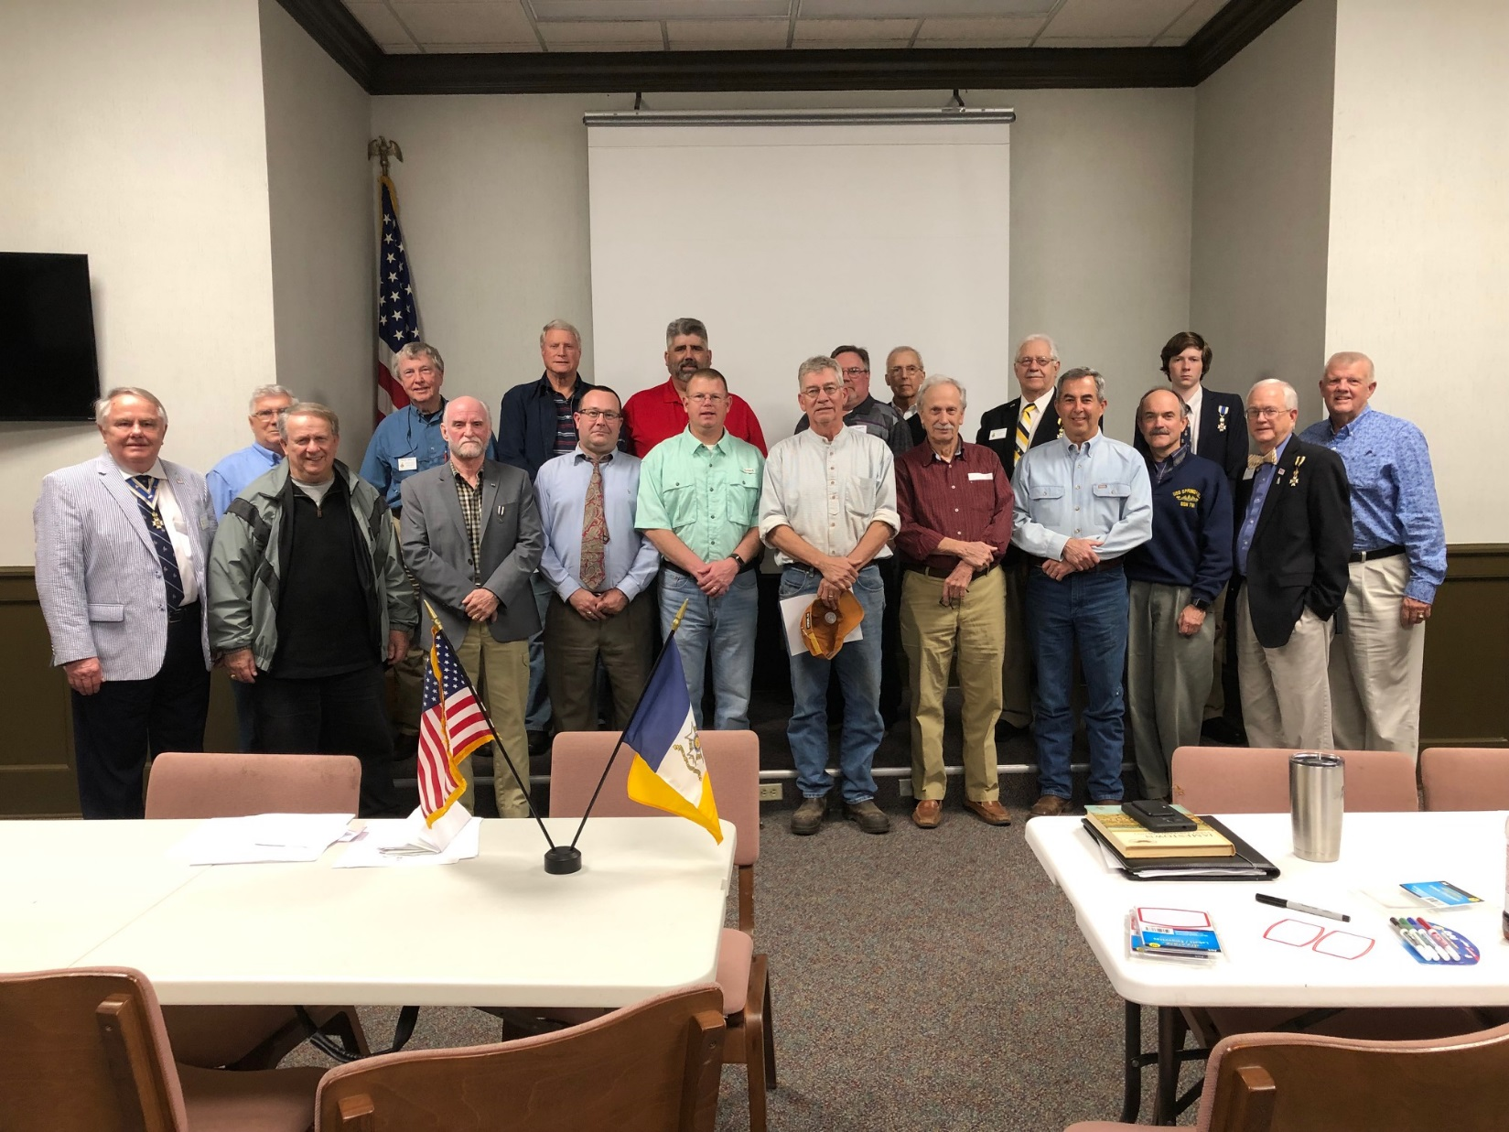
Pictured in Front Row Left to Right: Sonny Pittman, Jay Wilson, Dave Donehoo, Chris Lane, David Butler, Bill Morris, Jack Cheatham, David Moore, Gary Edwards, Alan Smith, and Dess Smith. Back Row Left to Right: Larry Buffington, Wilder Smith, Lewis Smith, Bill Tankersley, Thomas Reynolds, Bob Gibson, Alton McCloud, and Hayden McCloud.
Compatriot William Dawson “Bill” Morris suggested the name “Little River,” which was chosen by the majority of the membership at the March 21 meeting as the name for the new chapter. The Little River is a 72-mile long tributary of the Savannah River, forming borders between the counties of Wilkes, Warren, McDuffie, Lincoln, and Columbia. Kettle Creek, site of the Revolutionary War Battle on February 14, 1779, is a tributary of the Little River. Also at that meeting, Lewis Smith gave our first ever presentation, on a book he wrote titled “J. Edgar Thomson: The Georgia Rail Road Years.” We learned during this presentation that Thomson, namesake of our chapter’s headquarters, was responsible for the name “Atlanta” being chosen for the current capital city of Georgia, after it had previously been known as Terminus and then Marthasville.
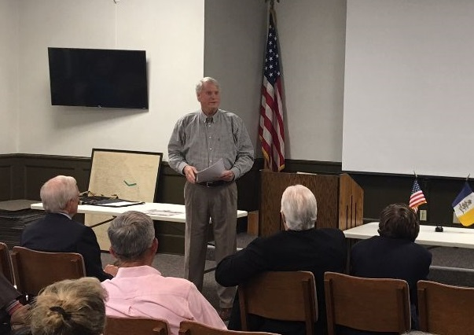 | 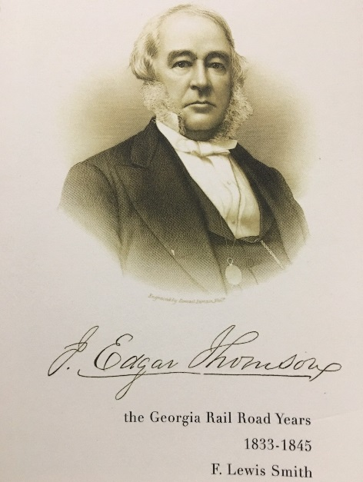
Lewis Smith speaks on J. Edgar Thomson | Lewis Smith’s Book

On July 29, 2019, at the Georgia Society SAR Board of Managers Meeting in Barnesville, William Tankersley and other SAR members from various East Fall Line Region Chapters presented the application for charter to the BOM. The application was approved by the BOM. Pictured below is the presentation.
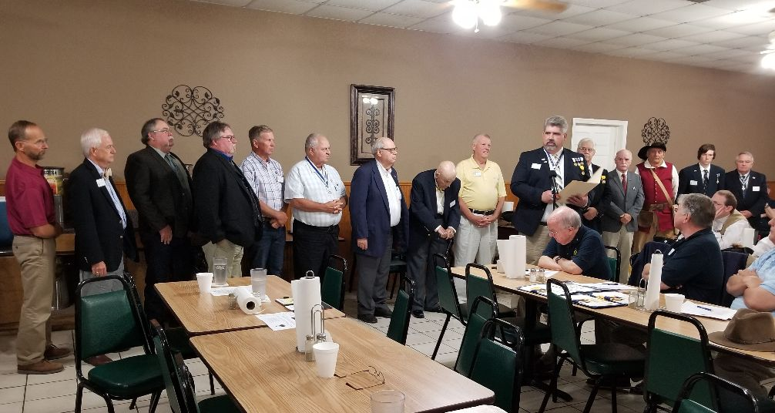

The charter was granted during a banquet held on Saturday, October 5, 2019, at the Belle Meade Country Club in Thomson. Georgia Society SAR President Scott Collins led the proceedings. National Society SAR President General 2018-19 Warren M. Alter from Arizona, and his lady Nancy, were in attendance.

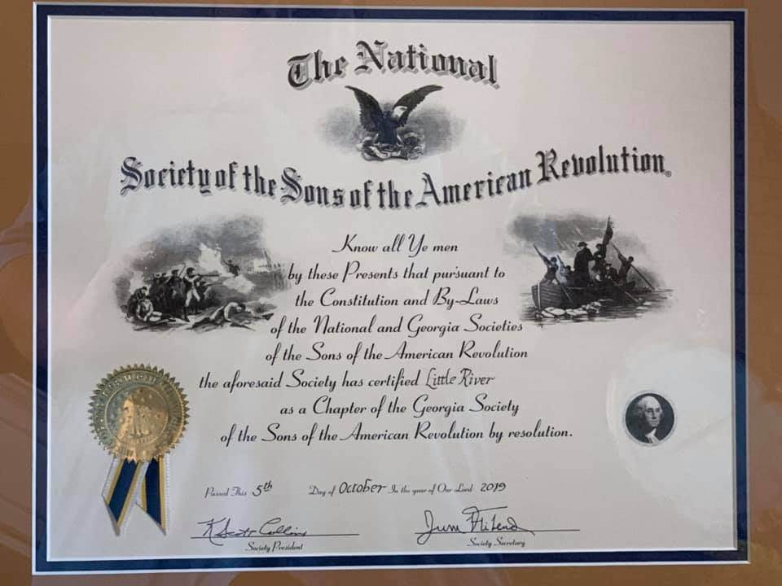
The Little River Chapter Charter Presented on October 5, 2019

A video of the charter banquet and installation ceremony may be viewed at https://www.youtube.com/watch?v=LKvCYstsoUU

Photographs of the charter banquet and installation ceremony may be viewed at
https://gasocietysar.org/photo-gallery-2/nggallery/gassar-chapter-events/Little-River-Charter-Banquet

