10.10F National Patriot Graves and Biographies Report Form

To obtain a copy of the latest National Patriot Graves and Biographies Report Form, begin by clicking on the link below, Patriot Research System (PRS) homepage
https://sarpatriots.sar.org/
From that page you can download the form by clicking on the link as circled below:
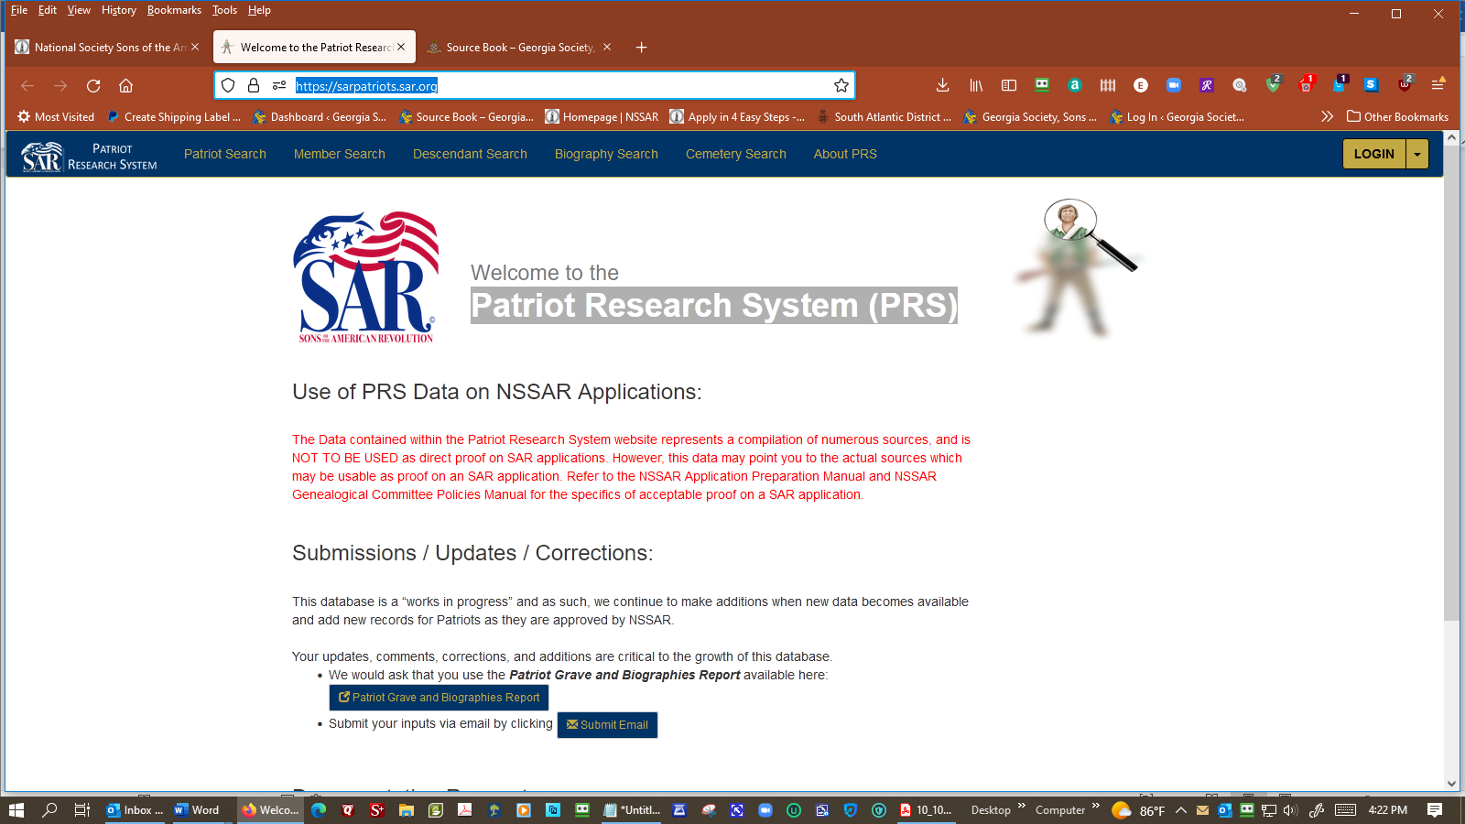

The Form will be uploaded to your “Downloads” folder.

